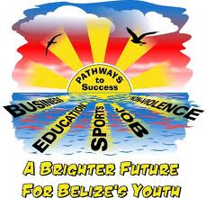

SOUTHSIDE YOUTH SUCCESS PROJECT
PATHWAYS TO EMPLOYMENT FOR AT-RISK YOUNG MEN
TRAINING AND APPRETICESHIP PROGRAMME
REPORT

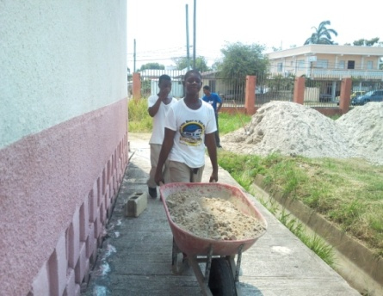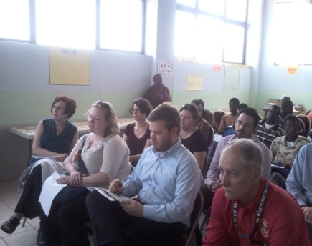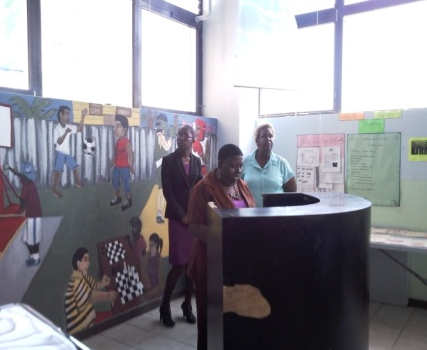
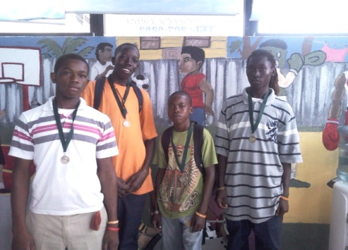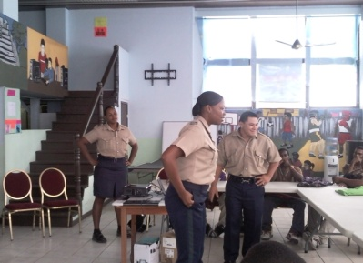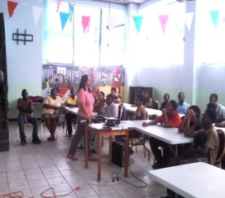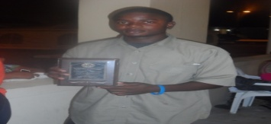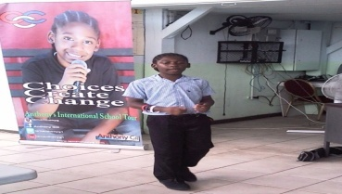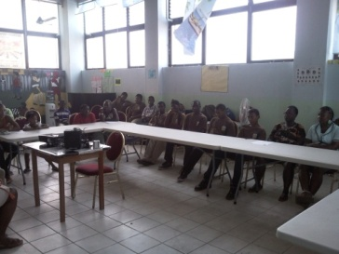

OVERVIEW

The Southside Youth Success Project was a two and a half year (2.5 years), training programme conducted at the Southside Drop-In Centre in Belize City in four cohorts of five (5) months respectively. This project was funded by the US Department of State’s Central America Regional Security Iniative and implemented by the Ministry of Education, Youth & Sports through the former Youth for the Future and the Current Departmnet of Youth Services. The Project was executed through the United Nation Development Programme. The Center recruited young men from the socio-economically deprived Southside of Belize City (SSBC), the most violent area of the country where homicide rates “exploded” in 2002 and showed little sign of falling at the time of the project’s inception in 2011 (Gayle, 2010: 289). At the heart of this violence are criminal gangs linked to the drug trade. These gangs are principally made up of young men between the ages of 15-29, who are the protagonists of homicidal violence; over 90% of all murders are committed by men against other men (Ibid: 54). Whilst there are multiple reasons for gang membership, one key factor is unemployment, which is rife amongst the youth population. Young men on Southside of Belize City are at the greatest risk of joining gangs and need positive employment opportunities to help prevent them from doing so. This is the central problem this project was used to address.

The aims of the Southside Youth Success Project:
- To promote standards of excellence and discipline that supported the young men in becoming productive citizens in society
- To play a vital role in reducing crime and violence with young men between the age of 14-17 in Belize City and promoted a positive path to adulthood
The Drop-In centre:
Is a safe space for youth and helps to keep them away from crime.
Provides youth with a supportive environment.
Promotes the use of information technology for research, training, leisure and other positive purposes

DURATION OF REPORT: January 2012- December 2013 - Three Cohorts

TARGET AGE GROUP: At-risk Belizean male 14yrs – 17 yrs

TARGET NUMBER: 100

TARGET AREA: Southside of Belize City

Summarized goals of the project:
The Southside Youth Success Project is to establish a coordinated system to provide ‘mentoring and life-skills’, ‘training’ and ‘job placements’ for vulnerable youths in Southside of Belize City. The principle goals were:

- Goal: To Establish efficient mechanisms to locate at-risk male youths in Southside Belize City.
- Result: This was accomplished through the assistance and partnership of the Port Loyola Center, Conscious Youth Development Programme (CYDP), Yarbrough Community Police, past trainees as well as parents liaising with other members of their community,

- Goal: To provide at-risk male youths in Southside of Belize City with initial mentoring, moral guidance & social values, life-skills and ‘job preparation’ training.

- Result: This goal was accomplished by bringing in Belizean Motivational Speakers of different age groups to share their life experiences. NGO’s and other Government agencies were brought in to conduct Life Skills Sessions with the trainees with its primary goal being to empower our youths to make better decision in regards to their life that will impact their community in a positive manner.

- Goal: To Place at-risk male youths in apprenticeship or job positions with project business / public partners.

- Result: The project accomplished the successful placement of 75 young men in apprenticeship positions over a period of 2 years

Southside Youth Success Project Achievement:
- An operational ‘drop-in’ centre and office in SSBC Established
- Established mentoring & training service. First, life-skills and social skills were given to the at-risk trainees; second they were trained in basic skills to ‘become employable’; financial numeracy skills were enriched.
- Seventy-five trainees were placed in Apprenticeship Training
- strong institutional project was established; developed reputation and expansion of partners within the business community, NGO’s and other GOB Ministries.
- Provided support and aftercare for young men and their families who were enrolled in the Programme

Identified and liaised with support systems in a collaborated effort for the individual trainees as well as their family based on their needs such as Human Development, Community Rehabilitation Department, Belize Family Court, Belize Social Security, Vital Statistic, Pantry and Boost Programme etc .

Developed, shaped and molded character traits through personal development sessions that were conducted at the center through DYS, NGO’s and Government Facilitators as well as motivational speakers.

Ensured that each young man had a legal identity – Poof of Birth, Birth Certificate & Social Security Card was also a part of the collaborated effort that the Center had engaged in.

The Southside Youth Success Programme was not only a Skill Training Programme but it was an avenue that the young men could have used as a testing ground (a yard stick) to evaluate themselves to see if they were ready for the work force or if they wanted to go back into the formal school setting or transition into other skills area that were available.

The Southside Youth Success Project operated as a Drop-In Center that offered assistance with homework and school projects to primary and high school students.

SYSP STAFF
The following personnel were actively engaged in the executing of programs for the SYSP Project.
Establish Strength | Department/Institution | Post | Duration
Four (4) | Department of Youth Services | Coordinator  Social Worker/Counselor  Vocational Instructor  Second Class Clerk  Life Skill Facilitator | One Year  One Year  Nine Months  Two years  Four Months
Seven (7) | Contractual Worker | Office Assistance  Consultant/Story Writing  M&E Personnel  Literacy Instructor  Skill Training Instructor ( Call Center Training)  Skill Training (Tour Guide)  Chess Instructor | One Year  Three Months  Six Months  Two Years  Three Months  Three Months  Three Months
Two (2)  One (1)  One (1)  One (1)  One (1) | Volunteers  Port Loyola Organization for Women  Belize Bible Institute  House of Shotokan  Independent  Unity Presbyterian | Cook  Spiritual Development  Karate & Physical Fitness  Personal Development & Boxing  Table Tennis | Ten Months  Ten Months  Seven months  Three Months  Three Months
Two (2) | Ministry of Public Service | Intern  Clerical and teaching support | Two Months

PARTICIPANTS
Participants enrolled in the programme were selected based upon the following criteria:
- Within the preferred age range of 14yrs – 17yrs
- Unemployed
- Out of School
- Considered at risk for inappropriate behavior
- Generally physically fit
- Amenable to signing a written contract for the duration of the program
- Residing on the Southside of Belize City

The number of participants applied to enter the Project for its duration was approximately one hundred and thirty-six (136).

Cohort | Total Applicant | Amount Referred | Amount Enrolled | Amount Dropped Out | Amount Completed
I | 25 | ------- | 25 | 07 | 18
II | 35 | 10 | 25 | 05 | 20
III | 50 | 14 | 36 | 05 | 31
IV | 26 | 06 | 20 | --- | 20 still in project
Total | 136 | 30 | 106 | 17 | 89

Trainees who had enrolled in the project were not successful in completing the curriculum based on several reasons such as:

- They had previous court cases before they were enrolled in the programme and were found guilty and remanded to Wagner’s Youth Facility
- Parents were transferred (employment) to another district
- Found employment to sustain their family needs
- Transferred to another skill programme after their court case was completed
- Parent became deceased while in the Cohort

DEMOGRAPHIC INFORMATION OF PARTICIPANTS

The demographic information of participants who were enrolled in the project is as follows:

No. of Participants by Geographic Area of Southside | No. Of Participants by Age Range | No. Of Participants by Ethnicity | No. of Participants by Religious Denomination | No. of Participants by Family Structure
10- Albert  14- Collect  28- Lake Independence  10- Mesopotamia  30- Port Loyola -  13- Queen Square | 13- 14yr old  51- 15yr old  34- 16yr old  08- 17yr old | 75 - Creole  09 - Mestizo  22- Garifuna | 05- Catholic  17- Evangelical  12-Methodist  15-Anglican  04-Nazarine  01-Pentecostal  01-Adventist  18 – No Religion | 75- Single Parent  12-Nuclear Family  19- Extended Family

PARTICIPANTS PLACEMENT

Total No. of  Participants who have completed the Project at December 2013 | School | Skill Programme | Employment | Unemployed
Sixty-nine  (69) | Primary School  One (01)  High School  One (01) Day  Two (2) Night School  Total in formal School Setting:  Four (04) | Eight (08) | Thirty-four (34) | Twenty- three (23)

Our records therefore indicates the following placement:

Education (Formal and Informal) 17.39%
Employment 49.28%
Unemployment 33.33%

67% gainfully occupied in employment and schools, while 33% are unemployed.

Factors that negatively affected placement of 33%:
Participants required longer Skill Training period before being place in employment.
Not sufficient skills acquired during the period for them to be placed in the workplace as a result of the emotional issues that at-risk youth come with that has to be dealt with before learning can occur

Duration of programme too short for the caliber of participant
Age range
Legal ramification for certain types of employment
Very few job opportunities available for that age range of young men
At the completion of Cohort III which was December there was no available programmes taking in participants at that time as the majority of programmes run for a school year as well as in the month of January most business places are not taking on employees (slow season).

PARTICIPANTS COURT CASES
Working in partnership with Community Rehabilitation Department, Belize Family Court, Human Development, Wagner’s Youth Facility and some prominent Lawyers SYSP took on the challenge of working with some of the trainees who had the following court cases in the Family Court. Approximately thirty-four percent (34%) of the participants enrolled in the programme had pending court cases in the Family Court.

Number of Participants | Charge(s)
One | Possession of Firearm
Three | Damage to Property
Two | Aggravated Assault
Six | Controlled Drugs
Two | Drug Trafficking
Five | Burglary/Handling of stolen goods
Four | Robbery/Burglary
Two | Robbery
One | Robbery/Grevious Harm
Two | Throwing Missile
Two | Arson

One participant in the programme had a case in the Supreme Court as he was sodomize and raped repeatedly by a male adult. The perpetrator was found guilty and was sentenced to five years imprisonment.

MEDICAL STATUS:

SYSP Monthly Reports revealed the following data of medical treatment conducted at the Center as well as at the Port Loyola Health Clinic.

Number of Participants | Symptoms | Treatment Administered at Center | Service Provider
60 | Headache | Tylenol & Advil | 5 – Health Clinic
13 | Sinus | Tylenol Cold & Sinus | None
10 | Allergies | Piriton  Calamine Lotion | 10 & Port Loyolla Health Clinic – Karl Heusner Memorial Hospital (KHMH)
05 | Asthma |  | 5 – KHMH
25 | Flu | Flu Pack  Tylenol | 25 – Health Clinic
03 | Sore Throat | Antibiotic treatment | 03- Health Clinic –
01 | Cut/abrasion | Stitching | 01-KHMH –
16 | Fever | Tylenol | 16- Health Clinic
08 | Chills & Fever |  | 08 – Health Clinic
13 | Vomiting (Food poisoning) | Andrews | 05- Health Clinic
23 | Cough & Cold |  | 23- Health Clinic
25 | -------------- |  | Full Medical Check-up & Port Loyola Health Clinic

FAMILY SUPPORT

The following family support was extended through the Project:

Social Programme Accessed
Boost Programme | Pantry | Family Counseling  At the Center | Family Counseling  Referrals (s) | Family Intervention
Four (4) Families | Eighteen  (18)  Families | Fifteen (15) Families | Twenty Trainees (20) & Four (4) families  Places of Referral  Community Rehabilitation Department (CRD)  Cleopatra White Health Clinic | Fifteen families  Assistance for Intervention  CRD  MHDSTPA  MOH  MOEYS  RESTORE Belize  CYDP  Central Bank of Belize  Legal Aid Office (Solicitor General’s Office

OTHER AREAS OF SUPPORT:

Working with the family to ensure all family members who were not holders of a legal identity obtained proof of birth certificates, birth certificates and social security cards

Legal Services for trainees

Medical Assistance

Financial Literacy skills and opening of bank or credit union accounts

Beneficiaries (trainees & siblings) of essential documents acquired through the SYSP

Document Acquired
Up-dated Social Security Card | First Social Security Card | Proof of Birth | First Birth Certificates | Pending (Awaiting approval)
Sixty-three – (63) | Sixteen (16) | Sixteen (16) | Sixteen (16) | One (1) birth certificate requiring signature of Register General

PROGRAM AREAS COVERED DURING THE PROJECT

Programs offered at the Center were geared towards empowering the trainees in Literacy & Numeracy, Skill Training, Life Skills, Spiritual Development, Physical, Moral and Social development, performances and achievements.

These Programs offered were:

Character Building/Personal Development/Literacy
- Personal Development
- Spiritual Development
- Physical Fitness
- Academic Assessments
- Literacy Sessions in Reading Comprehension, Numeracy, Grammar
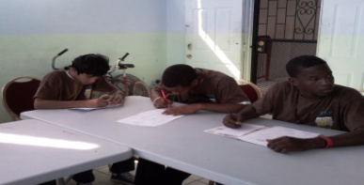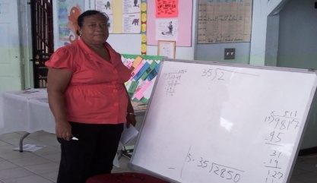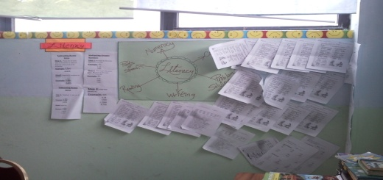
- Individual Counseling
- Group Counseling
- Health/Hygiene
- Plumbing
- Repairs to Small Machine
- Apprenticeship
Other Sessions Conducted were:
- Patriotism and civic pride

- Culture 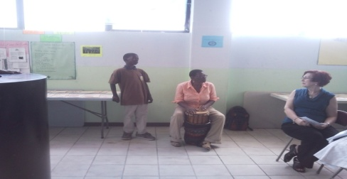
- Environmental Awareness
- Creative Arts
- Sports
- Introduction to Vocational Trades/Marketable Skills
- High School/ Vocational Placements

PERSONAL & SPIRTUAL DEVELOPMENT:
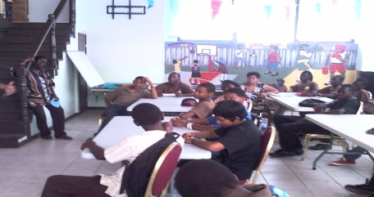Personal & Spiritual Development Sessions were conducted at the Center daily with all Trainees.
Three times a week on Tuesday, Wednesday and Thursday Group Counseling was conducted by Ms. Juliet Simmons, Professional Counselor from the Ministry of Health as well as with SYSP’s counselor in an effort to empower the trainees to make positive decisions and enable them to contribute to their community in a positive manner. These sessions ran simultaneously with each other. Individual counseling sessions were also conducted as the need arose for each individual.

SPIRITUAL DEVELOPMENT

Spiritual Development was conducted once a week on Mondays by Pastors and other spiritual leaders from different religious groups.

SPORTS

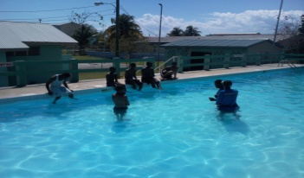 Basketball and Swimming were conducted on Wednesday with the main objective being to instill discipline, build resilient characters, confidence, team work and uniformity, leadership and self esteem.

Physical Fitness /Karate Enrichment Program were new programs integrated during Cohort III and sessions were conducted on Fridays at the House of Shotokan on Princess Margaret Drive. This program is in partnership with the proprietor and Master Karate /Marshal Art Trainer of the House of Shotokan, sensei Kelly. Different Motivational Speakers were also brought in to empower the trainees during these physical fitness sessions by Mr. Kelly at his facility.

Personal Development | Spiritual Development | Sports | Physical Fitness
Leadership  Separation & Trust  Grief/loss  Coping with Separation & Loss  Decision making  Responsibility  Developing Moral Values  Listening /Communication Skills  Anger Management  Discipline & Self Respect  Self Esteem  HIV/AIDS  Drug & Alcohol  Conflict Resolution  Confidence  Strengths/Weakness  Peer Pressure | Worshiping (singing)  Scripture Verses  Personal Testimonies by other young people  Mini church ceremony  Stories from the Bible  Bible Games  Bible Quiz | Sports Ethics  Basketball Techniques  Indoor Table Games (card, dominoes, checkers, crossword puzzles etc)  Table Tennis | Running  Sit-ups  Push-ups  Jumping Jacks  Warm-up  Cool-down

SKILLS TRAINING
Skill Training in Plumbing and Repairs to Small Machine were conducted at the Center. The Trainees also had the opportunity to visit several major Hardware Stores centrally located in the city as well as visit ITVET and two local workshops. These sessions ran simultaneously along with the other Literacy sessions.

COURSE OUTLINE FOR SKILLS TRAINING

Small Machine Repair | Information Technology | Plumbing
- Introduction to the Small Machine Course  - Workshop Safety Measures  - Types of Machines  - Basic Hand Tools Required for repairing machine  - Servicing of Weed Trimmers & Lawn Mowers  - Basic Trouble Shooting  - General Repairs  - How to use a Weed Trimmer & Lawn Mower  - Maintenance of Weed Trimmer & Lawn Mower | - Introduction to IT  - Rules & Regulation of the Computer Lab  - Basic Component of a computer  - Typing Master  - Use of Microsoft Programme  - Use of Excel Programme  - Computer Literacy Math & English Language  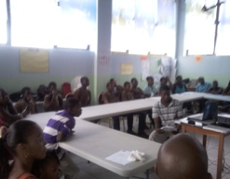  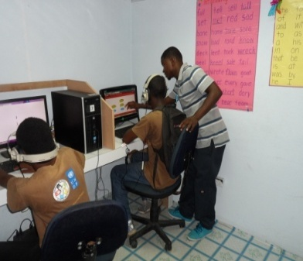 | - Introduction to the Plumbing Profession  - Workshop Safety Measures  - Measurements  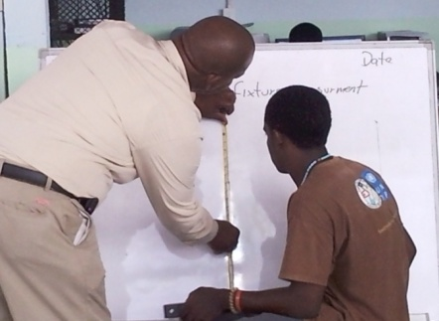  - Plumbing Terms & Definition  - Introduction to Basic Hand Tools Required in Plumbing  - Identifying the different types of plumbing fittings  - Field Visits to Hardware stores to view different plumbing supplies and materials  - Plumbing System  - Designing & Installing Plumbing System  - Residential & Commercial Plumbing Projects

Business processes Outsourcing Training | National Tour Guide Training | Etiquettes in the Workplace
- Basic Introduction to course  - Workplace Safety Measures  - Customer Care  - Customer service communication  - Creating two way communication  - Key boarding | - Basic introduction to course  - Effective Communication  - Different historical sites in Belize City  - People & Culture  - Maya Archaeology  - Rainforest  - Wild Life  - Understanding Tourism  - Understanding the visitor  - Visitor’s Expectations  - Tour Guide Responsibilities  - How to be professional  - Being responsible for the safety & well-being of the guest  - The welcome & Tour Brief  - Destination Presentations  - The Tour Wrap-up and Last Farewell | - Work Ethics  - Labour Law  - Customer Service  - Identifying your personal Skills  - Mock Interviews  - Resume Writing

APPRENTICESHIP TRAINING
Apprenticeship Training Placement Cohort II

Tuesday – Thursday Only

Business Places | Area of Apprenticeship Skills Gained | No. of Trainees
Ready Call & Clear Call | Customer Service  Call Centre Training | Eight
Smilling’s Meat | Cutting of Meat  Packaging of meat | One
Cisco Construction Company | Mechanic | Two
Dental Clinic | Cleaning of teeth | Two
 | Construction Work | Five
SYSP | Office Assistance | One
Princess | Waiter | Two
KHMH  Princess  Belize Red Cross  Belize Defence Force | General Repair & Maintenance  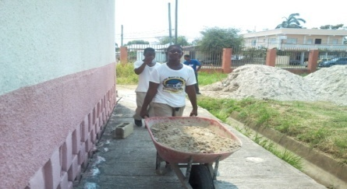  Constrution  AC Instalation | Fourteen
Action #01 Plumbing Service  Belize Defence Force  KHMH | Plumbing | Seven
Bottom Dollar  James Brodies  Belize Red Cross | Maintenance /Stores  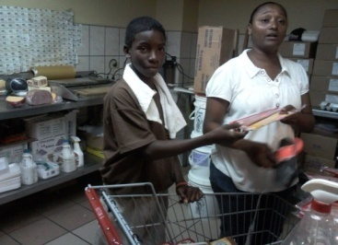  Stock Taking  Stocking of shelves  Pricing of Items  Bagging of groceries | Three
Jones Bus Service | Bus Conductor | One
Young’s Automotive | Electronic/Auto mechanic | One
Post Office | 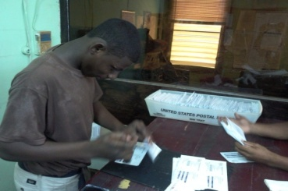  Sorting/Stamping of mail  Deliveing of mails | Four
West Street Baptist Church | Assistance in the Soup Kitchen  Serving and delivering of meals to the homeless and shut-ins  Packing of food baskets  Reading for the elderly | Four
Sanitation Department, Belize City Council | Cutting of Grass  Lawn Maintenance  Painting of park  Clearing and cleaning of drains & culvert  General up-grading of the city | Thirty

APPRENTICESHIP EVALUATION

Excellent 5, Very Good 4, Good 3, Fair 2, Poor 1

Cohort | Punctuality | Courtesy | Works well with others | Understand Tasks assigned | Completes Tasks
Cohort I | * | * | * | * | *
Cohort II | 4 | 3 | 4 | 4 | 5
Cohort III | 5 | 4 | 4 | 5 | 5

* No records available

TIME TABLE SCHEDULE

7:50 A.M –Morning Muster/Roll Call /Rap Session /Energizer……….

Time | Monday | Tuesday | Wednesday | Thursday | Friday
8:00 -9:00 | Spiritual Development | Life Skill  Ms. Bennett | Life Skill  Ms. Gill | Life Skill  Ms. Bennett | Physical Fitness
9:00-10:00 | Motivational Speaker | Literacy –Mrs. Parks  IT – Mr. Figueroa  Rotation of groups | Computer Literacy  Mrs. Parks  Creative Arts  Ms. Major | Computer Literacy  Mrs. Parks  Creative Arts | Physical Fitness  House of  ShotoKan
10:00-10:15 | B | R | E | A | K
10:15-11:00 | Literacy –Mrs. Parks  IT – Mr. Figueroa  Rotation of groups | Literacy –Mrs. Parks  IT – Mr. Figueroa  Rotation of groups | Computer Literacy  Mrs. Parks  Creative Arts  Ms. Major | Computer Literacy  Mrs. Parks  Creative Arts | Physical Fitness  House of  ShotoKan
11:00-12:00 | Literacy –Mrs. Parks  IT – Mr. Figueroa  Rotation of groups | Literacy –Mrs. Parks  IT – Mr. Figueroa  Rotation of groups | Computer Literacy  Mrs. Parks  Creative Arts  Ms. Major | Computer Literacy  Mrs. Parks  Creative Arts  Ms. Major | Motivational  Speaker
12:00-1:00 | L | U | N | C | H
1:00-2:00 | Small Engine Repairs  Mr. Lord | Small Engine Repairs  Mr. Lord | Swimming  YWCA | Small Engine Repairs  Mr. Lord | Drug  Education  NDAC
2:00 2:45 | Small Engine Repairs  Mr. Lord | Small Engine Repairs  Mr. Lord | Basketball  Supervised by:  Mr. Ramos | Small Engine Repairs  Mr. Lord | Life Skill  CYDP
2:45-3:00 | Reflection  Ms. McClaren | Reflection  Ms. McClaren | Reflection  Ms. McClaren | Reflection  Ms. McClaren | Reflection  Ms. McClaren
3:00-4:00 | Table Tennis/  Boxing  Duties/Detention | Karate & Self Defense  Duties/Detention | Boxing  Duties/  Detention | Karate & Self Defense  Board Games  Duties/Detention | Table Tennis  Board Games  Duties/  Detention

Summary of Time Table Schedule:

Topic Areas | Amount of Session per week | Contact hours per Week
Motivational Speaker | Three times a week | Three hours
Life Skills | Six Times a week | Six hours per wk.
Information Technology (IT) | Three Times a week | Six hours per wk.
Literacy | Three Times a week | Six hours per week
Small Engine Repair | Three Times a week | Six hours per week
Basketball | One time a week | One hour per week
Swimming | One time a week | One hour per week
Karate & Physical Fitness | One time a week | Three hours per week
Boxing | One Time a week | One hour per week
Reflection | Five Times a week | One hour per week

AFTER SCHOOL PROGRAM
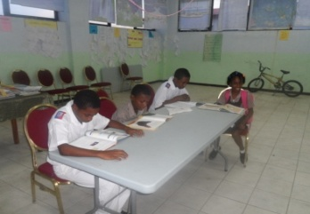 In an effort to assist students who didn’t have a place to study in the evening or access to a computer to complete school assignments and projects, the Afterschool Program was integrated into the work of the Center. This avenue created an opportunity for these young people to excel in school. The students who utilized the Center were from various Primary Schools and High Schools mainly from the Southside of the City.

Institutions of Beneficiaries of After School Program
Primary School | High School
- St.Mary’s Primary School  - Wesley Upper Primary  - Salvation Army  - Grace Primary School  - Adventist Primary School  - Baptist Primary School | - Anglican Cathedral College  - Wesley College  - Gwen Lizarraga High School Day & Evening Division  - St. Catharine Academy  - Edward P Yorke  - Nazarine High School  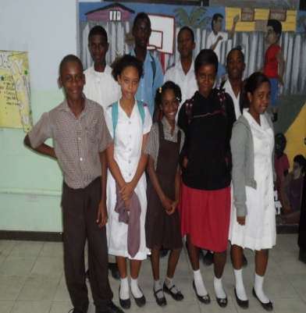

Achievements: Students who attended the Afterschool Program were empowered in the following area:

VOCABULARY AND GRAMMAR

Using the Dictionary
- Arrangement of a Dictionary
- Information in a Dictionary
- Finding the Right Meaning
- Word Content
- Spelling of words
- Capitalization of words
- Syllable Division of words
- Pronunciation of words

STUDYING AND TEST TAKING
To build and or improve afterschool students in studying skills, study habit and they were empowered to utilize different study strategies.

- Study Skills
- Adjusting your reading rate to your purpose
- Recognizing Main Idea
- Finding Details That Support Main Ideas
- Distinguishing Between Facts and Opinion
- Taking effective Study Notes
- Writing a Summary of Study Notes
- Preparing for and taking tests
- Preparing for Objective Tests
- Taking Objective Tests
- Multiple Choice Tests
- Fill In the Blank Questions
- How to answer True or False Questions
- How to write Short Answers
- Matching Questions
- Preparing for Essay Tests
- Answering the Different Kinds of Essay Question

PROJECTS
- Participating in Group Project
- Photo copying
- How to Research using the computer
- School Based Assessment Preparation

READING
- Comprehension
- Visualizing
- Picture reading
- Analyzing
- Interpreting
- Processing

SUPPORT SERVICES
The following support services were provided for walk in at the Center who came for assistance:

Type of Assistance, Support or Referral | Comment
Educational Assistance | Students still in school
High School Placement | Recommendation was made, student was accepted in high school, student still in high school
Educational Assistance | Student received fees and was able to graduate
Placement | Assessment was conducted by National Resource Center for Inclusive Education (NARCIE)  , as a result this student was placed in an environment suitable for his learning
Study Space for Scholarship Recipients  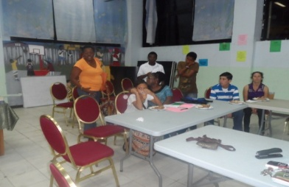 | Eleven students from the Scholarship Recipients for Friends in Support of the Anglican Diocese of Belize (FSADB) were given the opportunity to utilize the Center to do their homework, school project or as a studying area for them. This invitation was extended as some of the students were at risk of losing their scholarship because of their grades. After coming to the center on a daily basis for the last four months in 2013 their report cards and assessment report reveals a considerable improvement in grades.

COMMUNITY SERVICE

The following community services were conducted by the staff and trainees:
- Feed the Homeless at Battle Field Park on Regent Street and Albert Street
- Cleaning of BTL Park, Regent Street & Albert Street
- Cleaning of Marine Parade & North Front Street
- Cleaning of St. Mary’s Church yard and Ethel Vargas Pre-school
- Cleaning of Portion (2miles) of George Price Highway

The Programme provided the opportunity for the following schools to allow their students to conduct their community service at the Center in exchange for literacy skills training.

Name of Institution | Community Service
Wesley College | Photo copying & Filing
Gwen Lizaraga High School | Assistance with after school students
St. Martin De Porres Primary School | Centre Clean-Up

This opportunity was also extended for the Belize Family Court and Community Rehabilitation Department to send juvenile first time offenders to conduct community service at the Center while at the same time they could embrace the opportunity to complete their homework under supervision.

SPECIAL EVENTS & EXPOSURE

Special Events were the highlight of the Programme for the trainees. Hence, the Center embraced every event and outings available as a stepping stone to develop the trainees socially, recreationally and educationally. These events included the following:

Activities | Location | Participants | Source of Funding
Trainee’s Retreat | Banana Bank | Trainees/Staff/Parents | UNDP
Special Meal  “Valentine Day” | SYSP Center | Trainees/Staff/Parents | Staff
SYSP Board Meeting | Coastal Zone Management | SYSP Board Members/DYS | UNDP
US Embassy Visit | SYSP Center | US Embassy Delegates, UNDP Representatives, DYS Director & Staff, Trainees/Staff/Parents | UNDP
Tour of BDF Facility  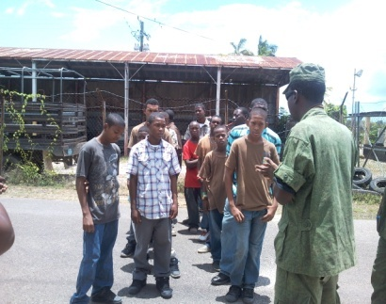 | Price Barrack, Ladyville | Trainees,Staff, Volunteer & Parents | UNDP
Mother’s Day Outing  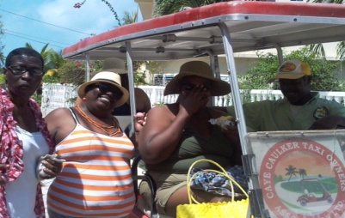 | Caye Caulker | SYSP Staff | Unanimous Donor
Launching of Youth Policy | NICH | Trainees/Staff | None required
Launching of SYSP  Documentary “The Good, The Bad & The Nobody Road | Port Loyolla Library | Trainees, Parents, Mininster and representative of MOE, Gov Officials, NGO’s, | UNDP
Cohort II Graduation Ceremony | UWI | Trainees/Staff/Parents
Sports/Personal Development Camp  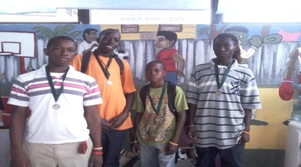 | Port Loyolla Organization for Women | Trainees/Staff/Parents | Port Loyolla Organization for Women
Arts & Craft Summer Camp | St. Mary’s Primary School |  | DYS
Financial Literacy Programme | Anglican Cathedral College  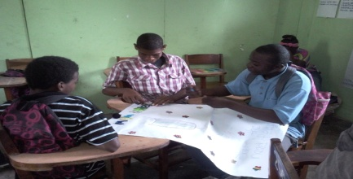 | SYSP Trainees & Other High School Students | MOE
ITVET Open Day | ITVET | SYSP Staff & Trainees | UNDP
NBA Derick Anderson Motivational Presentation  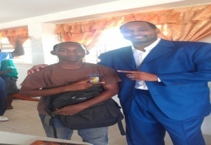 | Rockville Village | Youth Hostel Residents & NYCSC Challengers  SYSP Trainees  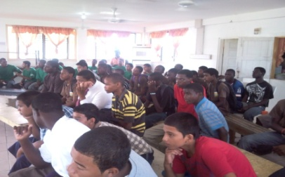 | UNDP
Intern Appreciation Day | SYSP | SYSP Staff & Trainees | Staff
Launching of Old Belize Book | House of Culture | SYSP Staff & Trainees | House of Culture
Medical Check-up | Port Loyola Health Clinic | Trainees | MOH
Distribution of Boots | SYSP | Trainees/Parents/Staff
Sports Day  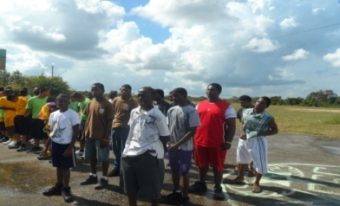 | NYCSC Campus,  Rockville | SYSP Trainees, NYCSC Cadets, Residents of Youth Hostel | UNDP
Christmas Luncheon | SYSP  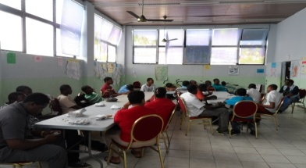 | SYSP Staff , Volunteer & Trainees | UNDP
Distribution of Working Boots  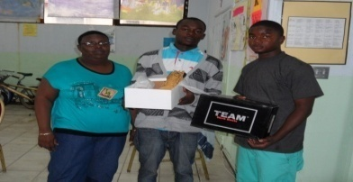 | SYSP | SYSP Trainees  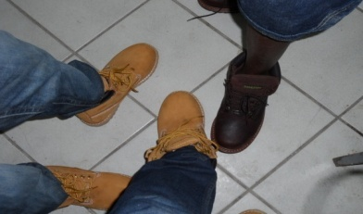 | UNDP
Youth Award, DYS  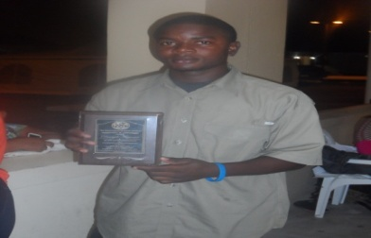 | ITVET | DYS, Youth Workers & Agencies, NGO’s | DYS

WORKSHOP/TRAINING
(STAFF)
In House Workshop and Training were organized and conducted for the staff in the following areas:

Topic/ Sessions | Facilitator | Venue | Amt of  Participants
Effective Communication | Ms. Manzanarez | SYSP Center | National Youth Cadet Service Corp & SYSP Staff
Managing Anger | Ms. Manzanarez | SYSP Center | National Youth Cadet Service Corp & SYSP Staff

Individual Staff Training, Workshop & Training Courses:

Staff | Training Area | Host | Certification
Ms. Bennett | Counseling Workshop | MOE | Certificate of Participation
Ms. Bennett | Parenting Workshop | UNICEF | Certificate of Participation
Ms. Bennett | MOP (Me Others & Property) | CYDP | Certificate of Participation
Ms. Major | Working with Youths | DYS | None
Ms. Parks | Computer Literacy Workshop | RESTORE Belize | None
Mr. Figueroa | Computer Literacy Workshop | RESTORE Belize | None
Mr. Figueroa | Working with Youths | DYS | None

SPECIAL TRAINEES TRAINING

Workshop and Special Training were conducted on behalf of SYSP by different organizations and individuals in the areas of:

Topic Area | Facilitator | Orgnaization
Conflict Resolution/  Anger Management | Mrs. Myrna Manzanares | Private Consultant
Sexual and Reproductive Health Education | Department of Youth Services | Department of Youth Services
Drug & Alcohol Abuse | Ms. Christine | Drug Abuse Council
Etiquette in the workplace | Ms. Mapyee Smith | Private Consultant
Personal Hygiene | Mrs. Christina Martinez | Ministry of Health
Police Youth Initiative | Mr. Nunez & Ms. Melanie Price | RESTORE Belize
Crime Stoppers Belize | Ms. Chris Garcia | Crime Stoppers Belize
‘I Am Me” | Mr. Cacho | PASMO
Financial Literacy | MOE | MOE
Sports | MOE | MOE
Tour Guide In Belize | Mr. Rudy Burgos
Tour Guide Operator | Mr. Rudy Burgos
Tourism & Sexual Exploitation | Mr. Raymond Mossiah | BTB
Work Ethics  Labour Law  Customer Service  Identifying Skills  Mock Interviews  Resume Writing | Labour Department | Labour Department
Role of Social Security |  | Belize Social Security
STD & HIV Training |  | HECOPAB
Self Esteem  Six Pillars of Self EsteemTips for Building Self EsteemHealthy Habits for Building Self Esteem  Conflict Resolution  Conflict Resolution Techniques  Effective Communication Skills  Anger Management  Defining Anger  - Anger Inventory  - Identifying Anger Triggers  Personal Anger Sequence  Decision Making  Identifying various ways of making decisions  Effective Decision Making  Practice Making difficult decisions  Goal Setting  Defining Goal  Identifying short term & long term goals  Process for setting goals & trying to achieve them  Explore personal, academic and vocational goals | CYDP  CYDP | CYDP
Youth Rights and the Law | Nigel Hawke | Office of the Solicitor General

MOTIVATIONAL SPEAKERS AS EMPOWERMENT TOOL
Motivational Speakers were brought in on a weekly basis to share their life experiences in an effort to empower and encourage the trainees to continue on a positive path towards their goal.

Facilitator (s) | Topic
Mr. Timmy Stamp | Not choosing the path of a Gangster 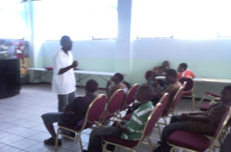
Mr. Linsberg Graham | Changing the course of your life  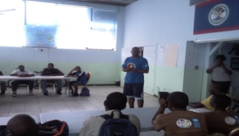
Officer Petillo, Yarbrough Community Policing | Safety & Police assisting young people as Mediator  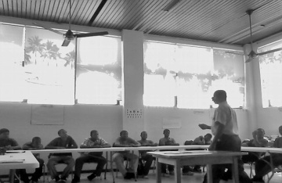
Mr. Raymond Mossiah, BTB | Sexual Exploitation of children & Tourism  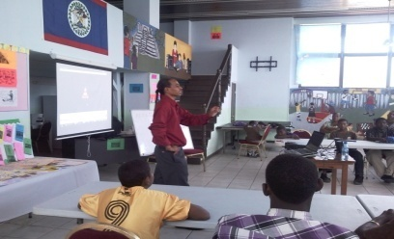
Mr. Richard Terry | The power to excel from life experiences
Mr. Glenfod Baptist | Losing a love one as a result of gang rivalry
Pastor Ernest Betson | Working your way to the Top
Mr. Edison Staine | Patriotism
Mr. Wole Parks Actor from the movie “Premium Rush” | 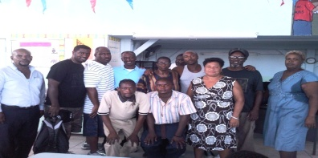
Anthony Gill (eleven year old Motivational Speaker) | Choices Create Change  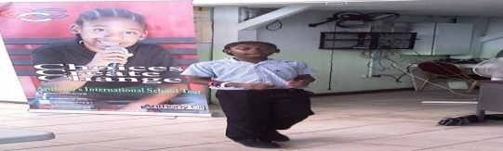
Mr. Rudy Burgos | Tour guiding in Belize
Mr. Mark Usher | PROTO
Police Sub-Station II | Being a Good Citizen/Abiding by the Law

Risk
The risk log was put in place at the Center to document the anticipated risk (an uncertain event or set of events that, should it occur, will have an effect of achievement of the objectives (time, cost, scope, quality)

Category | Description | Counter-measures | Impact | Probability | Proximity
Environmental | Not meeting target number and specific clientele per Cohort | Liaising with parents, schools, community workers, Truancy Dep. Social Worker and DYS Belize Youth Empowerment Officers to assist in the recruitment. | High | Low | Immediate to long tem
Environmental | Inability to ensure that young men stick to the programme from start to finish. | Identify mentors within the community. | High | High | Medium to long term
 |  | DYS Counselor/Social Worker posted at the Centre kept track of trainees attendances and followed up by conducting home visit with those who had missed sessions. | High | High | Medium to long term
 |  | Developed a partnership with Truancy Dept., Socialworker and worked with parents to ensure that their children attend the program on a daily basis. | High | High | Medium to long term
Environmental | High rate of truancy and absentees | Having Social Worker liaised with parents and Truancy Dept. for support and assistance. | High | High | Immediate to long tem
Political | Changes within the National Ministry leadership and Municipal Council | If administration changed, there have to be immediate contact with new administration detailing the importance and urgency of the project and it PMU | Low | Low | Short to Medium term
Political | Sustainability of Program and Building use after the completion of the project with UNDP | At the completion of the project, ensure that another agreement is signed to continue using the space  Getting MOE support and commitment to continue the program | Modest | Low | Long Term
Natural | Hurricane season 2013 | Ensure that project can begin quickly after a hurricane  Ensure that all Equipments and appliances are properly secured | Modest | High | Medium to long term
Natural | Risk of delays as a result of flooding from rains | Ensured that classes were not cancelled due to flooding of the building. Ensured that young men assisted promptly with mopping up flood waters and quick resumption of classes occured thereafter | High | Modest | Medium to long term
Environmental | Easy exposure to theft and burglary from participants and others who access the centre | Ensured that all personnel who leave the Centre lock all the doors and that all equipments are accounted for at the end of the day before participants are allowed to leave.  Visitors Log put in place.  Staff who opened the centre and who closed the centre signs a log of opening and closing the centre to track who opens and closes the centre on any given day | High | High | Medium to long term
 | Risk of Delays and theft as a result of leaving the centre open for inspection during bomb threats | Plan - Relocate to the Thurton Library when a bomb threat occurs therefore, young men are accounted for as well as training can resume in this safe location  Immediately do inventory check upon return after bomb threat evacuation | Modest | Modest | Short to Long Term

Issues: Relevant events or situations that have happened (or are happening), were not planned, and which impact upon the approved Project Plan. If escalated beyond a certain point it may have required management action. In can be a concern, query, a request for change, suggestion or off-specification raised during a project.

Type  (RFC, Off-Spec or Problem/  Concern) | Description of Issue | Desired Outcome | Status | Completed Actions | Planned Future Actions
Problem/  Concern | A few Apprenticeship placements were cancelled.  Two trainees were taken off their job sight as they didn’t show the level of Responsibly and Maturity required in the work place | Work Ethic and work preparedness status for employed Trainees | closed | Additional work Ethics training provided at the center | Additional work Ethics training provided at the center  Identify beforehand the weaker Trainees and give additional training
Problem/  Concern | Identifying Landscaping Instructor  Submission of Résumé by Instructors | Hiring of an Instructor | Closed | Acquiring MOE & ITVET assistance to identify Instructors  Submit résumé to UNDP | Acquiring MOE assistance and or place add in newspaper to identify Instructors in the future
Problem/  Concern | Identifying Small machine repair Instructor  Submission of Résumé by Instructors | Hiring of an Instructor | Closed | Acquiring MOE & ITVET assistance to identify Instructors  Submit résumé to UNDP | Acquiring MOE assistance and or place add in newspaper to identify Instructors in the future
Problem/  Concern | Identifying Vendors who would be able to provide estimate for the construction of additional computer table and computer dividers | Submission of Quotes  Hiring of Vendor | Closed | Vendors Identified  Quotes submitted | Construction of computer table and divider
Problem/  Concern | Identify Arts & Craft Instructor | Hiring of a Arts &Craft Instructor | Open | Acquire MOE &ITVET assistance to identify Instructor | Installation of prospect instead of plastic  Create a Bank or directory for Instructors
Problem/  Concern | Identify a Karate Instructor | Hiring of a Karate Instructor | Closed | Acquire MOE &ITVET assistance to identify Instructor | Create a Bank or directory for Instructors
Problem/  Concern | Flooding of the Centre is evitable. | Problem is resolved by drying the Centre out. | Open | Gutteing has been built to minimize the level of flooding | Students will go to Thurton Library when flooding is uncontrollable in order to continue training so that it is uninterrupted.
Problem/  Concern | Availability of transportation to Conduct Home Visit for trainees of Cohort II | Conduct Home Visit | open | Liaising with A.G Director of DYS and NYCSC Manager for assistance  Use of Consultant Vehicle  Completion of home visit | Councillor/Social Worker submitting request in advanced to DYS  Lobbying for a vehicle
Problem/  Concern | Availability of transportation to check and Visit for trainees of Cohort II that will be on apprenticeship III | Conduct Apprenticeship check and visits | open | Liaising with Director and NYCSC Manager for assistance  Use of public transportation  Completion of apprenticeship visits and checks | Councillor/Social Worker submitting request in advanced to DYS  Lobbying for a vehicle
Problem/  Concern | Lack of commitment from NGOs to conduct Life Skills Sessions on a timely basis with trainees as was previously agreed on. | Conducting of Life Skill Sessions for trainees | Closed | Meeting with NGOs  Amendment of schedule to facilitate the Facilitators | Getting full commitment from NGOs as well as their trainers
Problem/  Concern | Lack of Professionalism of Vocational facilitator | Professionalism of Vocational facilitator at the Work Place | Closed | Meeting with Instructor  Notifying DYS of Staff performance  Memorandum issued for tardiness, absenteeism | Posting only DYS staff that is committed and willing to work with at-risk youth

PROJECTED PLAN FOR THE PROGRAMME AFTER MARCH - 2014

The following are anticipated projection for the Center for 2014:

- After School Program Extension
Develop a cadre of volunteers to assist with the After School Program thus extending the program to more students.

- WEEKEND ACTIVITIES
The following are activities that will be introduced and will be conducted on the weekends:
- Adult Literacy Class – Being offered to Parents & interested adult in the community
- Parenting Workshop for present trainees parents as well as previous parents from the cohorts
- Staff Empowerment Training for SYSP Staff as well as staff from the other two sister institution under the DYS

- NEW PROJECTS

- Indoor urban gardening
- Yard Maintenance in partnership with the Belize City Council & Trimming Program in partnership with Cruz Barber Shop

ADDITIONAL STAFF
Volunteer assistance will be sought through the Jesuit Foundation for the assistance of volunteers that will be attached to the program. These volunteers will play a major role in the program. With the increase of man power a more effective monitoring and supervision system of the trainees will be set in place, in an effort to eliminate any mishap or incident.

MONITORING/ EVALUATION OF PROGRAMME
Additional Assessment Forms will be created and implemented that will allow us to assess and create data on the trainees performances and on the programs carried out at the center.

RENEWED & STRENGHTHENING OF PARTNERSHIP

Renewed & Strengthening of partnership | New Partnership
- Truancy Department  - Community Rehabilitation Department  - Ministry of Human Development  - Ministry of Health  - KHMH  - National Youth Cadet Service Corp  - National 4-H  - NDACC  - Yarbrough Community Police  - Labour Department  - Belize Social Security Board  - RESTORE Belize  - Crime Stoppers  - BFLA  - YMCA  - House of Shotokan  - BDF  - Belize Red Cross  - Port Loyola Organization for Women  - Belize Social Security Board  - Vital Statistics Unit  - UNICEF  - Labour Department  - HECOPAB  - PASMO  - BTB  - Human Rights Commission of Belize  - Belize Family Court  - September Celebration Committee  - Belize City Council  - Ready Call Centre | YWCA  ITVET  Police Cadet  NICH  Dr. Bennett, Canada  Rotary Club  BEST  Beltraide  Jesuit Foundation  Catholic Mission  ITVET

______________________
Ms. Sandra McClaren
Coordinator
SYSP

